8. List Linux commands in /usr/bin that start with letter w

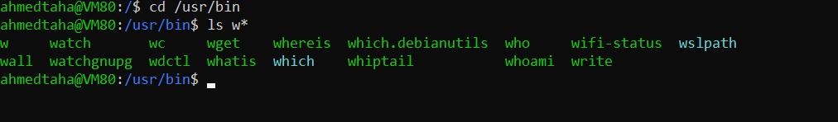

11. Display the man pages of passwd the command and the file sequentially in one command.

man -a passwd



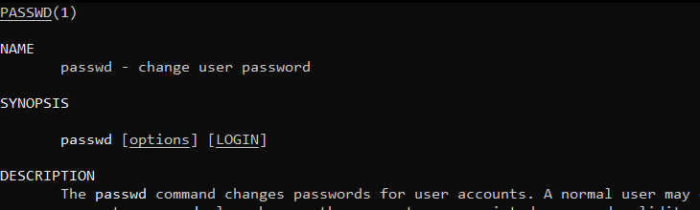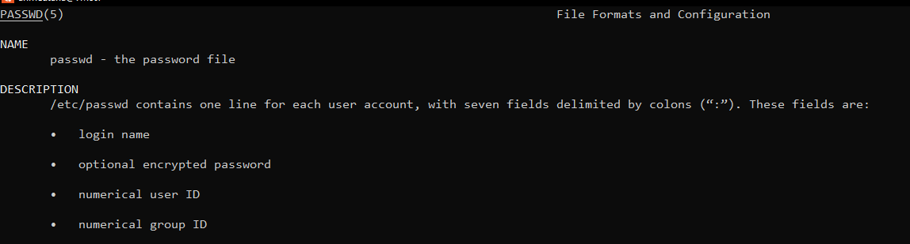

12. Display the man page of the passwd file.



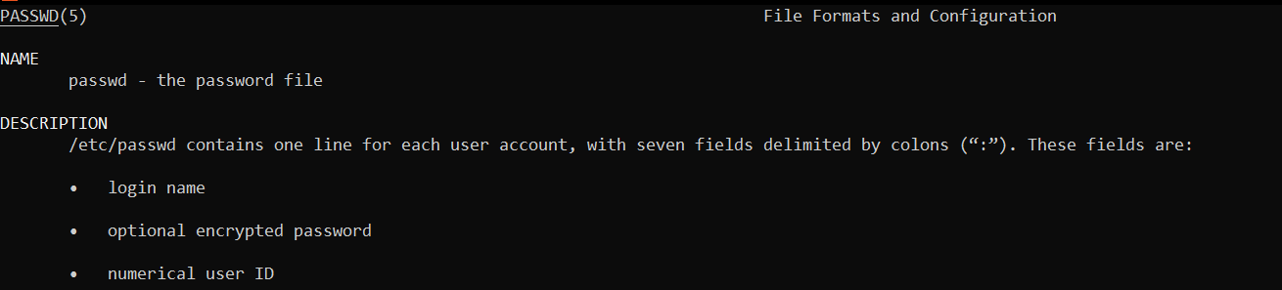

13. Display a list of all the commands that contain the keyword passwd in their man page.

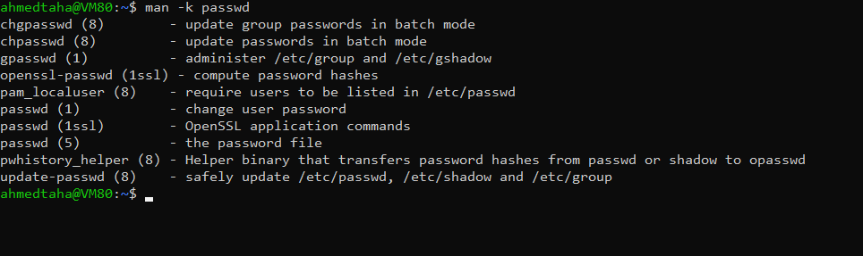

=============================================================================

**Lab2**

1)

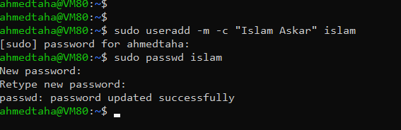

2)

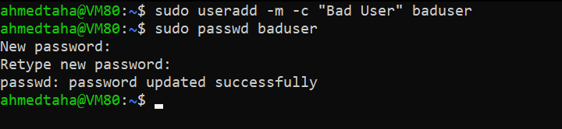

3)



4)

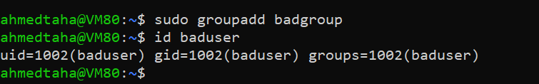

5)

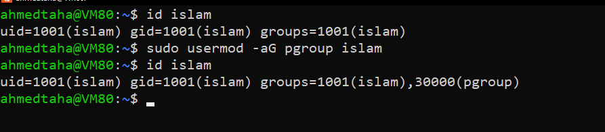

6)

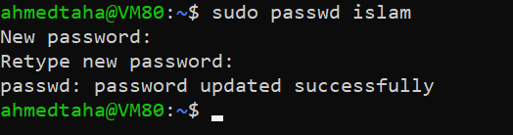

7)

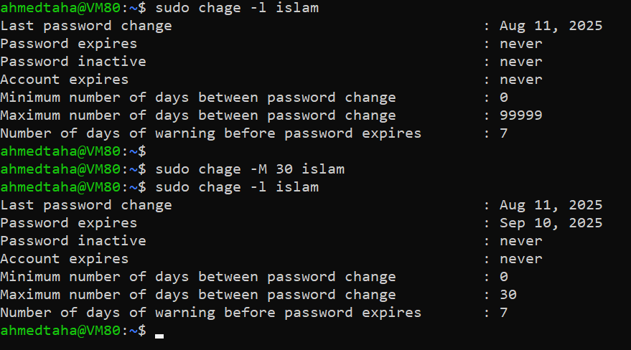

8)

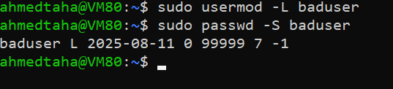

9)

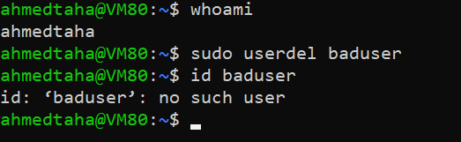

10)

